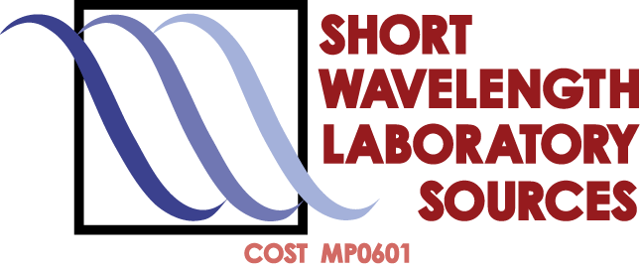

COST MP0601 Short Wavelength Laboratory Sources
Kraków, May 27–28, 2010

Wednesday, May 26th
17:00 Registration
Thursday, May 27th
08:30 Registration (continued)
09:15 Paweł Olko, Janusz Lekki & Alan Michette
Welcome and introduction

Session 1. Chair: Francois de Gaufridy de Dortan
09:30 Sergey Zakharov
High brightness EUV light source system development for actinic mask metrology
09:55 Inna Bukreeva
Talbot effect in x-ray waveguides
10:20 Alan Michette
An update on the UK Smart X-Ray Optics project
10:45 Coffee and posters

Session 2. Chair: Slawka Pfauntsch
11:15 István Földes
Cleaning KrF laser pulses with plasma mirrors
11:40 Jeremy Frey
Imaging soft x-ray production and scattering
12:05 Ulf Zastrau
Temperature and K -yield radial distributions in laser-produced solid density plasmas
12:55 Lunch and posters

Session 3. Chair: Reiner Dietsch
14:00 Torsten Feigl
Coating of World's largest EUV mirror
14:25 Alexei Erko
Parallel fs x-ray spectrometer
14:50 Frantisek Dubecky
Progress in low energy X-ray spectrometry using semi-insulating GaAs detectors
15:15 Gianni Monaco
SiC thin films deposited at high temperature by means of excimer and Nd-YaG lasers
15:40 Andreas Oelsner
X-ray area detectors with temporal resolution in the picosecond range
16:05 Coffee and posters
16:45 MCM meeting part I
20:00 Social Dinner

Friday, May 28th
09:30 MCM meeting part II
11:00 Coffee and posters

Session 6. Chair: Peter Hoghoj
11:30 Henryk Fiedorowicz
Application of laser plasma EUV sources in processing polymers and nanoimaging
11:55 Frank Barkusky
Damage and ablation of optical materials under focused EUV radiation from a table-top LPP source
12:20 Yevhen Zabila
Direct laser interference patterning of magnetic films
12:45 Lunch and posters

Session 7. Chair: Ulf Hinze
14:00 Alan Michette
Report on MC meeting
14:25 Andrzej Bartnik
EUV-initiated surface changes in polymers
14:50 Ruben Seisyan
ISTC grant #3857; design of two colour - two pulse LPP EUV source and 4m high NA EUV objective for laboratory nanolithography tool
15:15 Coffee and posters

Session 8. Chair: Gerry O’Sullivan
16:00 John Costello
Multiphoton ionization in intense EUV free electron laser fields
16:25 Paolo Di Lazzaro
Novel anti-counterfeiting technique by EUV lithography
19:00 Concert
20:15 Farewell party
Posters
P1. Vladimir Ac – Application of diamond in X-ray sources
P2. Jozef Kaiser – Application of the 46.9 nm capillary-discharge based table-top Ar+8 XUV laser for laser ablation
P3. Sebastian Bożek – Cells irradiation complementary lines at IFJ PAN
P4. Blair Lebert & Wafa Kezzar – Coherence properties of a EUV/soft x-ray source for interference lithography
P5. Zdenko Zápražný – Conditions for absorption and phase contrast mechanisms in imaging with a laboratory microfocus X-ray source
P6. Klaus Mann – EUV/XUV radiation: a versatile tool for structural and chemical surface analysis
P7. Francois de Gaufridy de Dortan – Fast temporal ionisation code for an hydro-radiative code
P8. Jakub Bielecki – Investigations of microstructure and hydraulic permeability of rocks samples by means of x-ray computed microtomography measurement and simulations using lattice Boltzmann method
P9. Ladislav Pina – Microfocus high brightness x-ray tubes metrology
P10. Vasily Zakharov – Modeling of EUV spectra from nonequilibrium xenon plasma with high energy electrons
P11. Paul Duggan – Silson x-ray optics
P12. Maurizio Donarelli – Table-top interference lithography as a tool to fabricate lasers emitting in the third window of optical communications.
P13. Marcin Perzanowski – Theoretical background of the direct laser interference patterning method
P14. Jerzy Pełka – Towards new biosensors. Structure and properties of electrospun nanofibers composed of ZnO
P15. Larissa Juschkin – Extreme ultraviolet radiation: a versatile tool for nanometrology
P16. Serhiy Danylyuk – EUV interference lithography with a gas discharge source
P17. Veronika Pickova – Interaction experiments in the fs laboratory at CTU

